Install Prometheus and Grafana on a Linux EC2 machine, connect Prometheus to Grafana, and create a dashboard to view metrics.

**Solution:-**

Created an EC2 Instance(named as Monitoring)

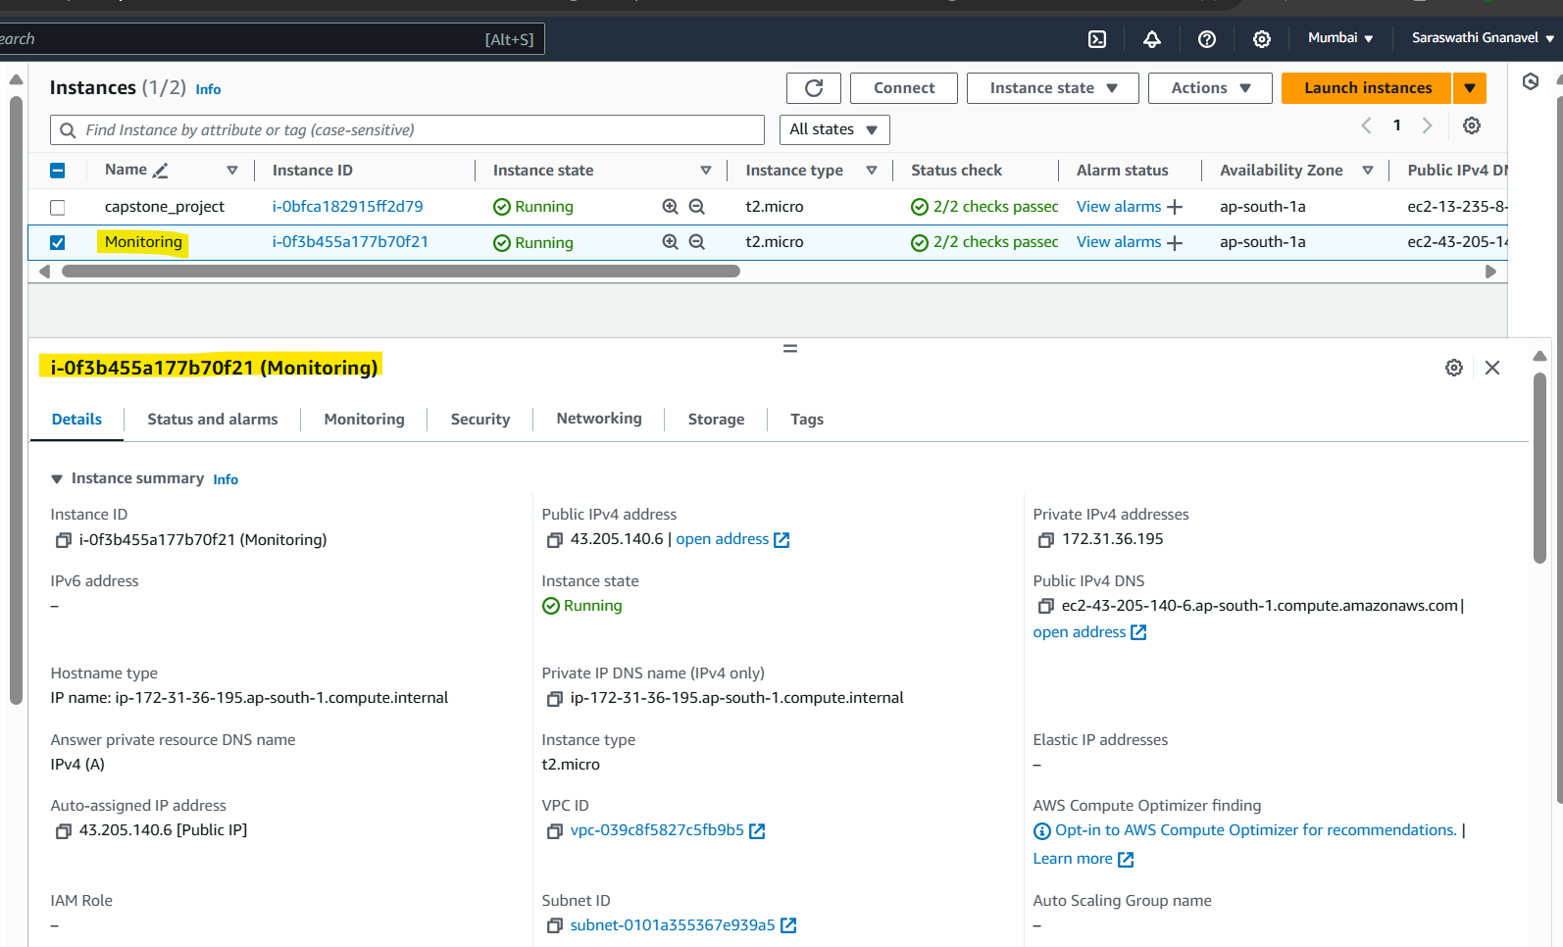

Updated inbound rules of Security group to allow all IPv4 addresses

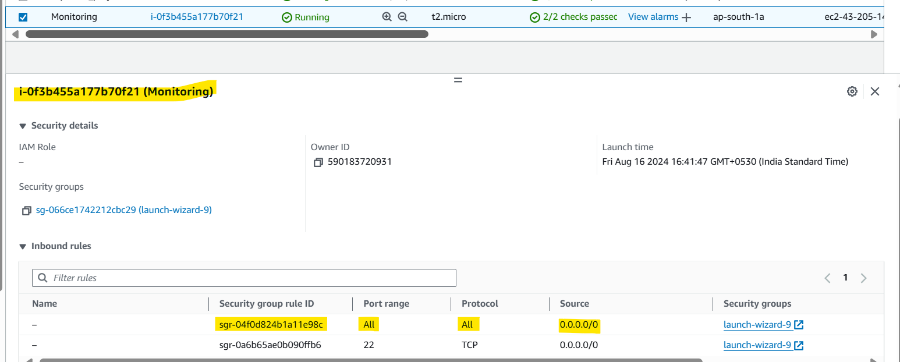

Installing Prometheus on that instance

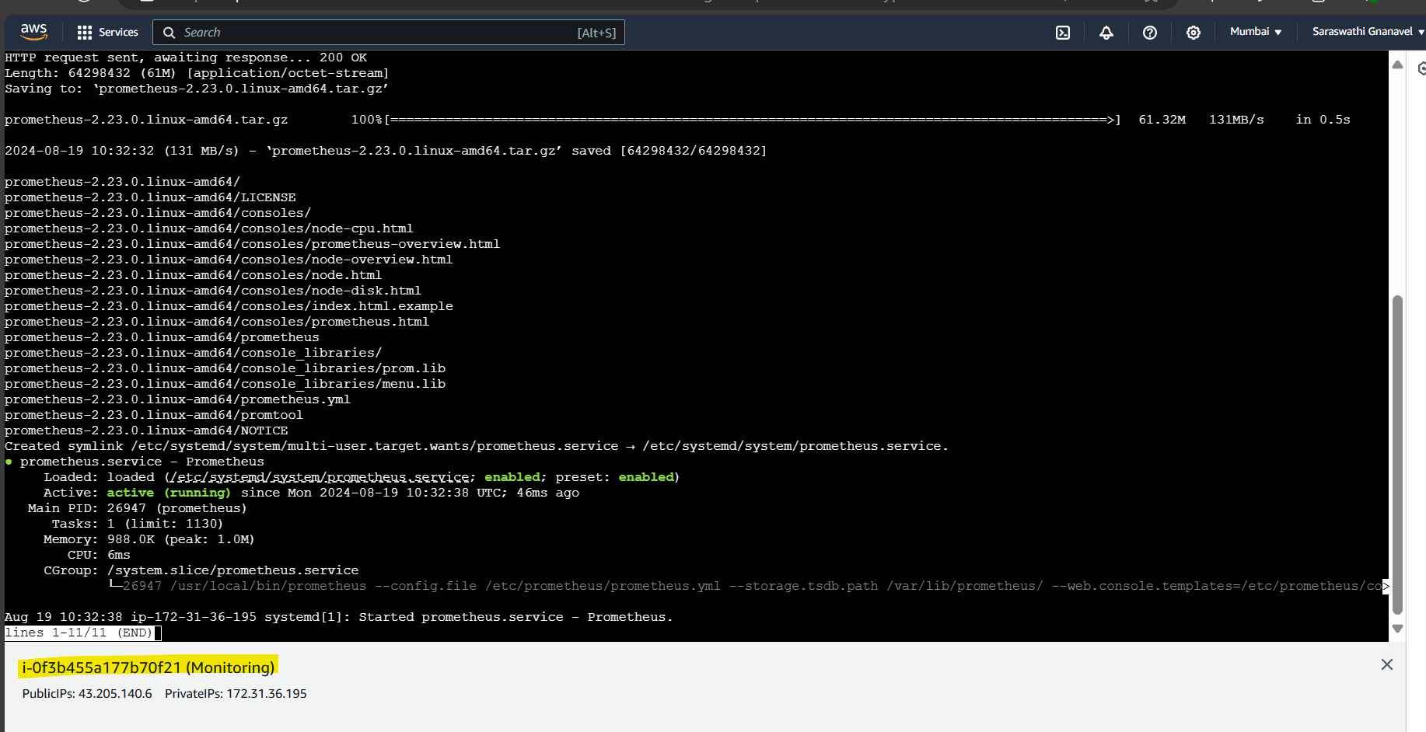

Prometheus is running

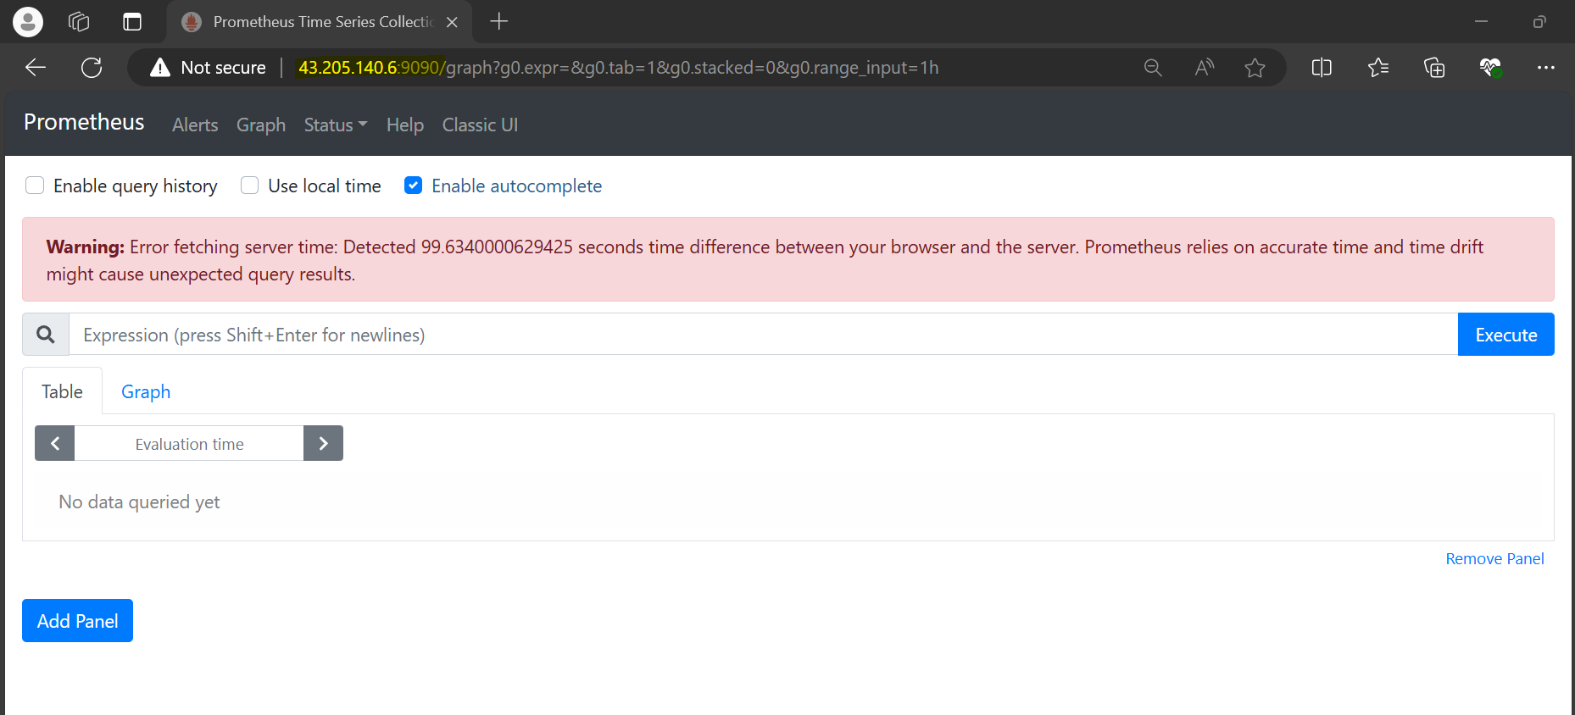Installing node-exporter in the same instance

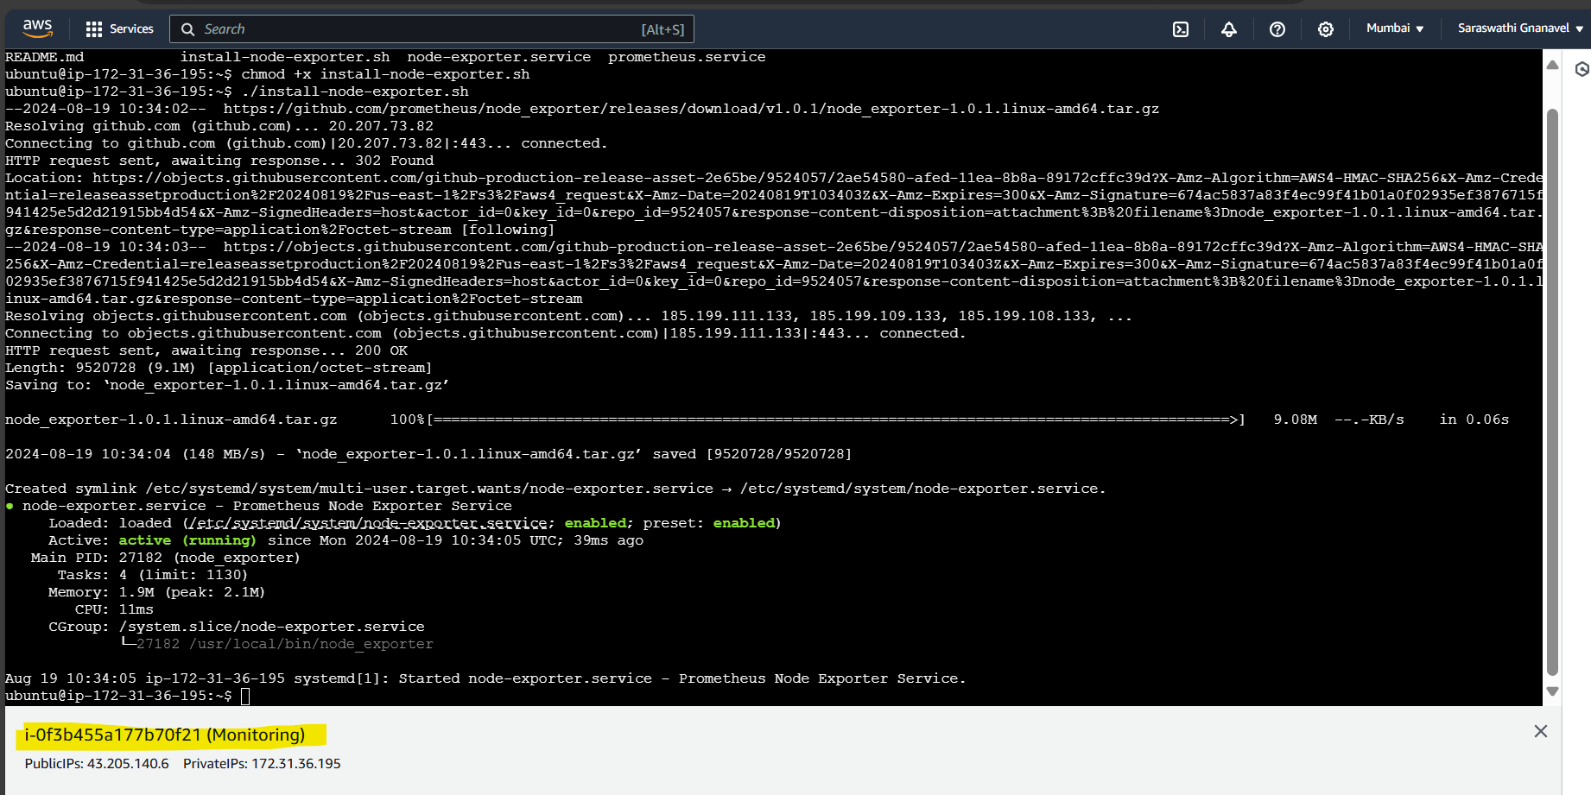

it is in running state



Configured Prometheus and node-exporter via prometheus.yml file

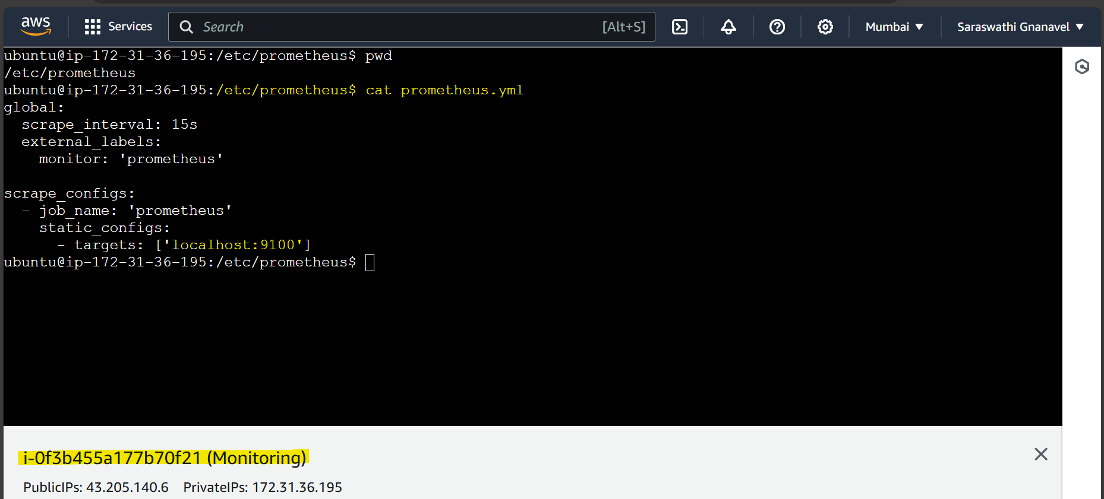

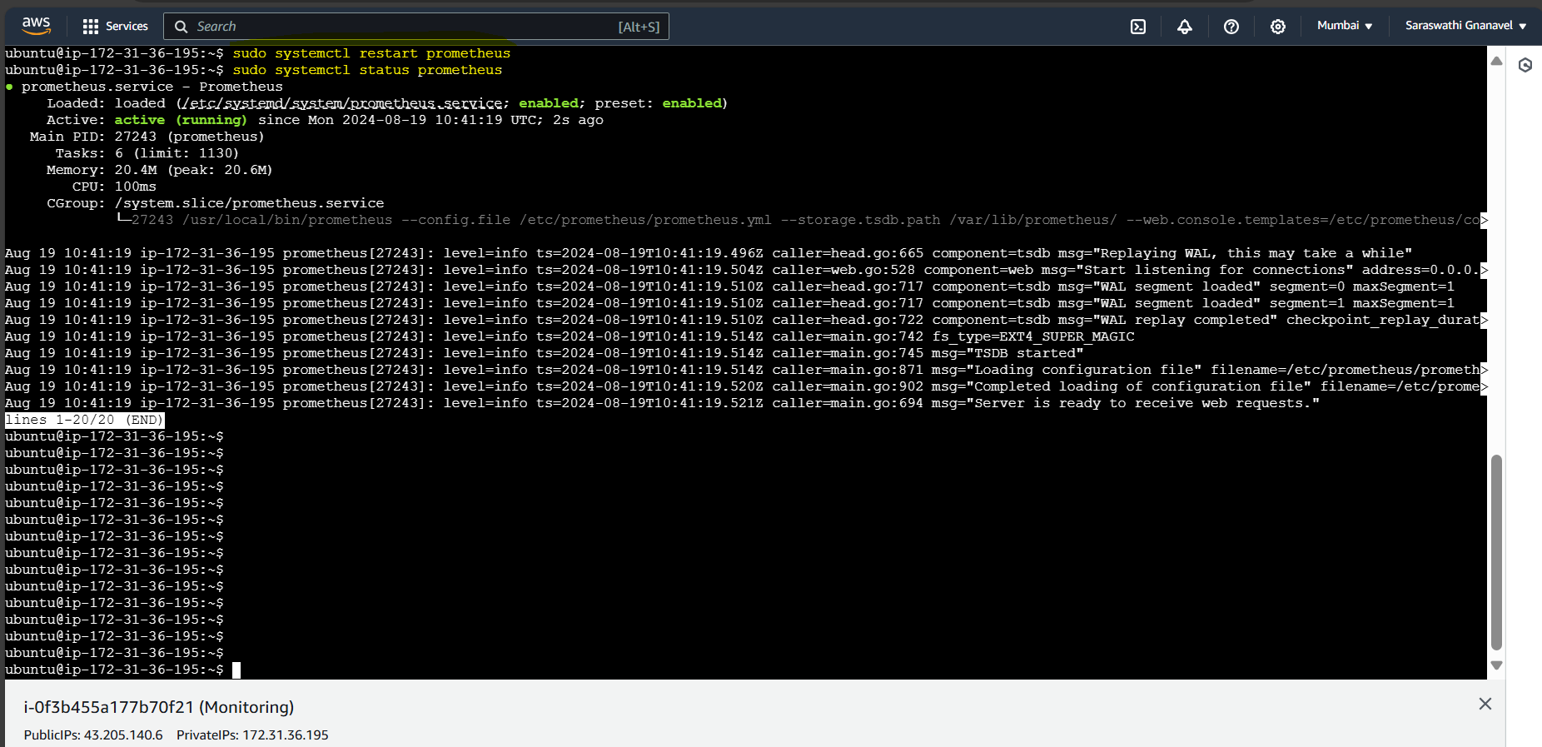

Installed Grafana in same instance

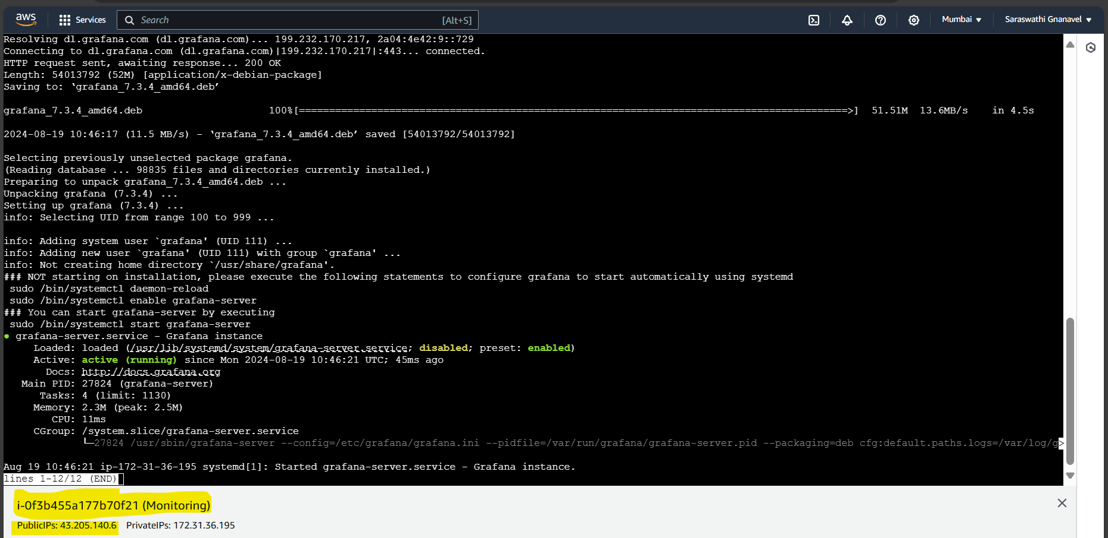

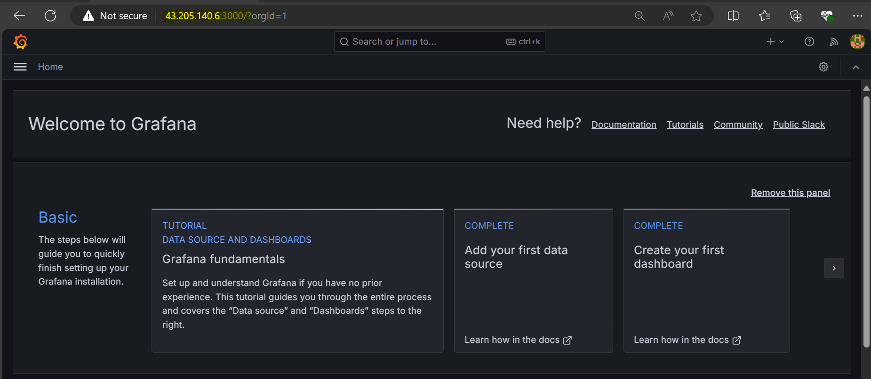

Added the Data source as Prometheus

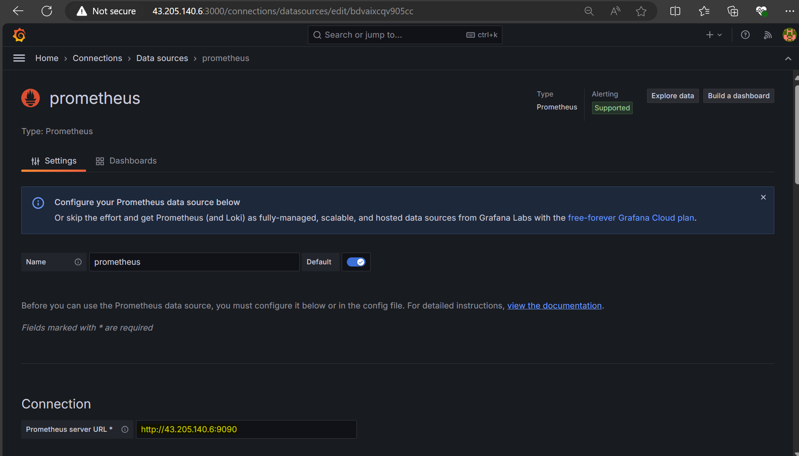

Imported Grafana dashboard from Grafana labs

Referred the following url :- <https://grafana.com/grafana/dashboards/1860-node-exporter-full/>

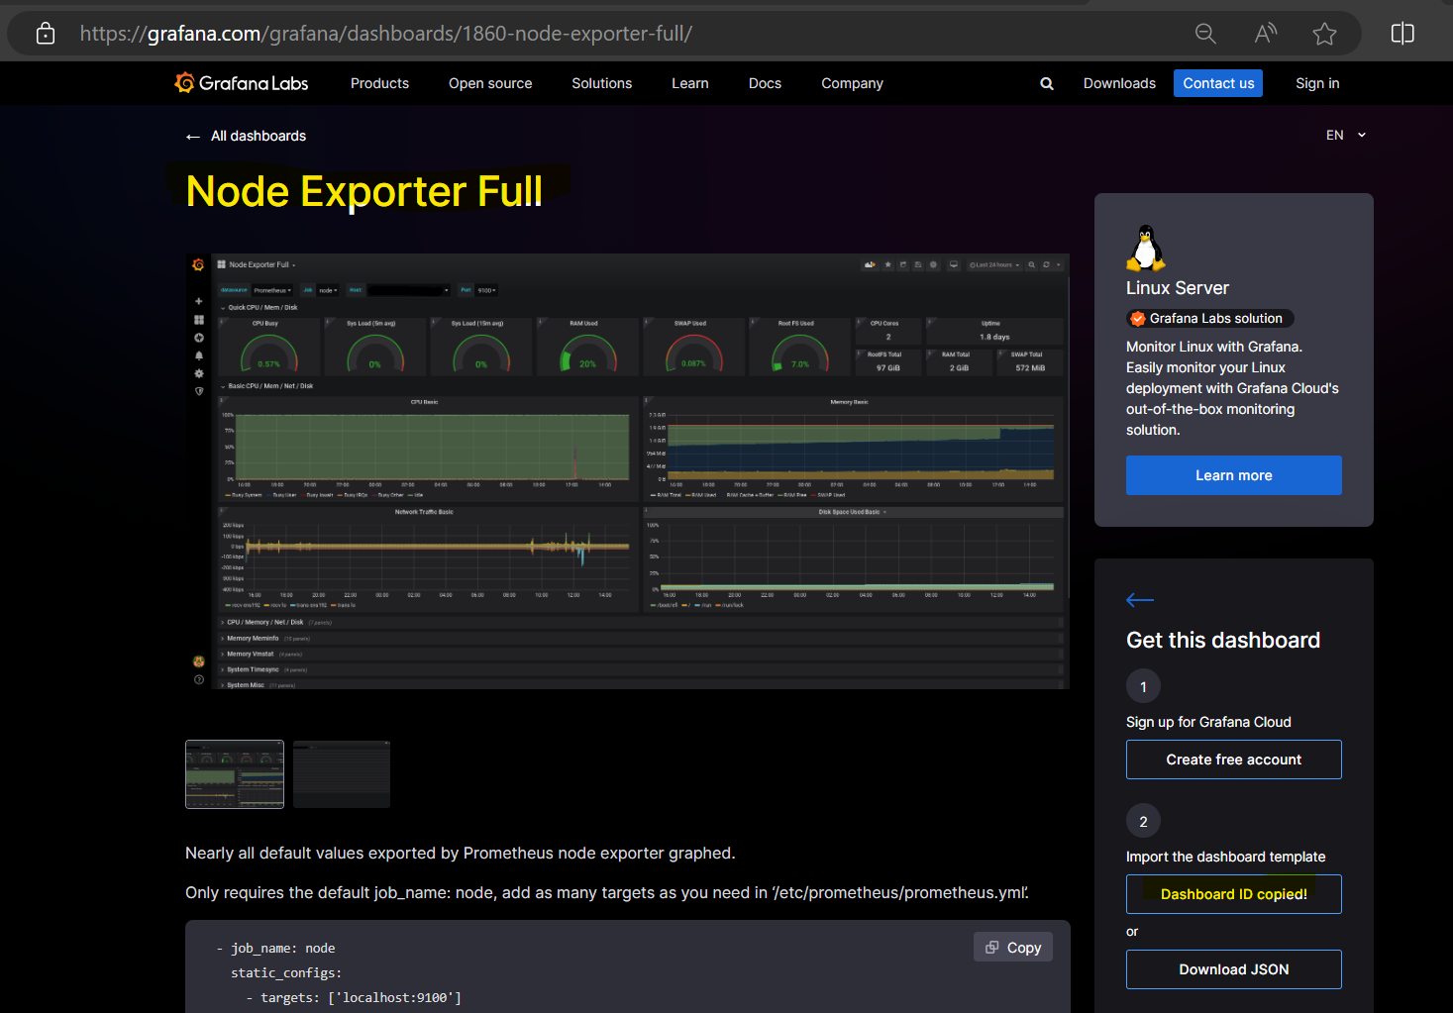

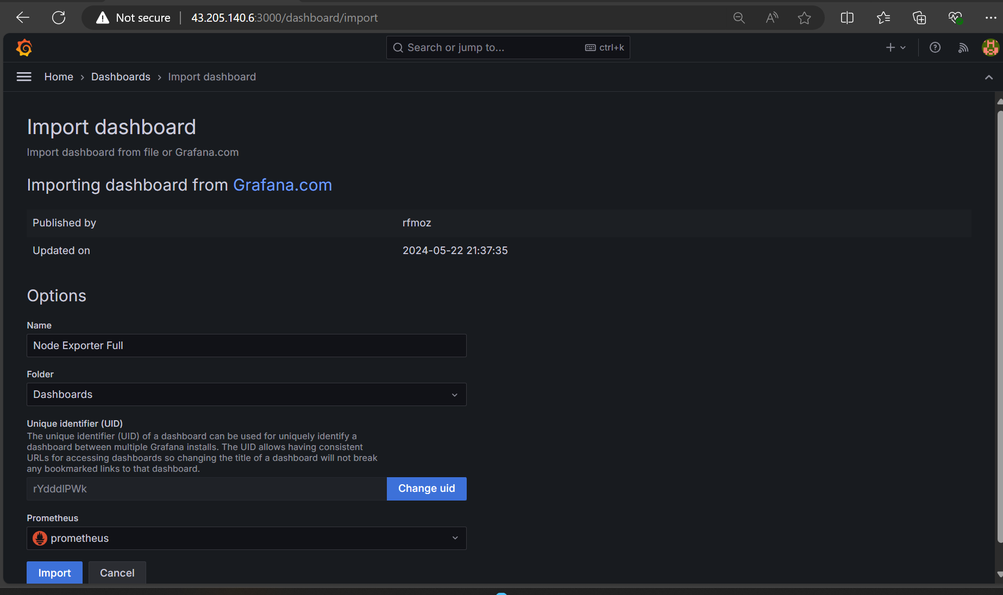

Installed node-exporter in capstone_project(PublicIPs: 13.235.8.176)

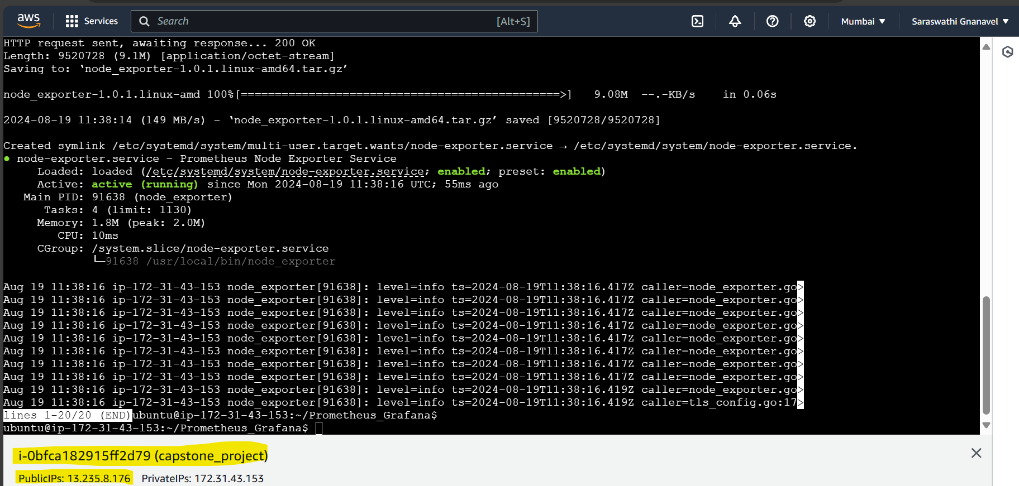

Dashboard set up is completed and below you can able of Monitoring instance the metrics

